**COMPILER DESIGN**

**Computation of Leading and Trailing**

**Aim:**

To compute leading and trailing for a given production.

**Language Used:**

Python

**Algorithm:**

1. Create a python file
2. Make an input of number of terminals and non-terminals
3. Following the rulesfor finding leading, we find the leading and store it in the array:

(i) ‘a’ is a in LEADING (A) if

LEADING(A)={a}

A→aY, here Y is a grammar symbol

(or)

A→XaY, here X is a single non-

terminal

(ii) If there is a production

A→BX and ‘a’ is in LEADING(B) then

‘a’ will be in LEADING (A)

1. Similarly for Trailing, apply the rules given to find them and store it in the array:

TRAILING(A)={a}

(i) ‘a’ is in TRAILING (A) if

A→Xa, here X is a grammar symbol (or)

A→XaY, here X is a single non-terminal

(ii) If there is a production

A→XB

TRAILING(B) will be in TRAILING(A)

where X is a grammar symbol

1. Print the following 2 arrays to output the leading and trailing of the given production.

Input string -

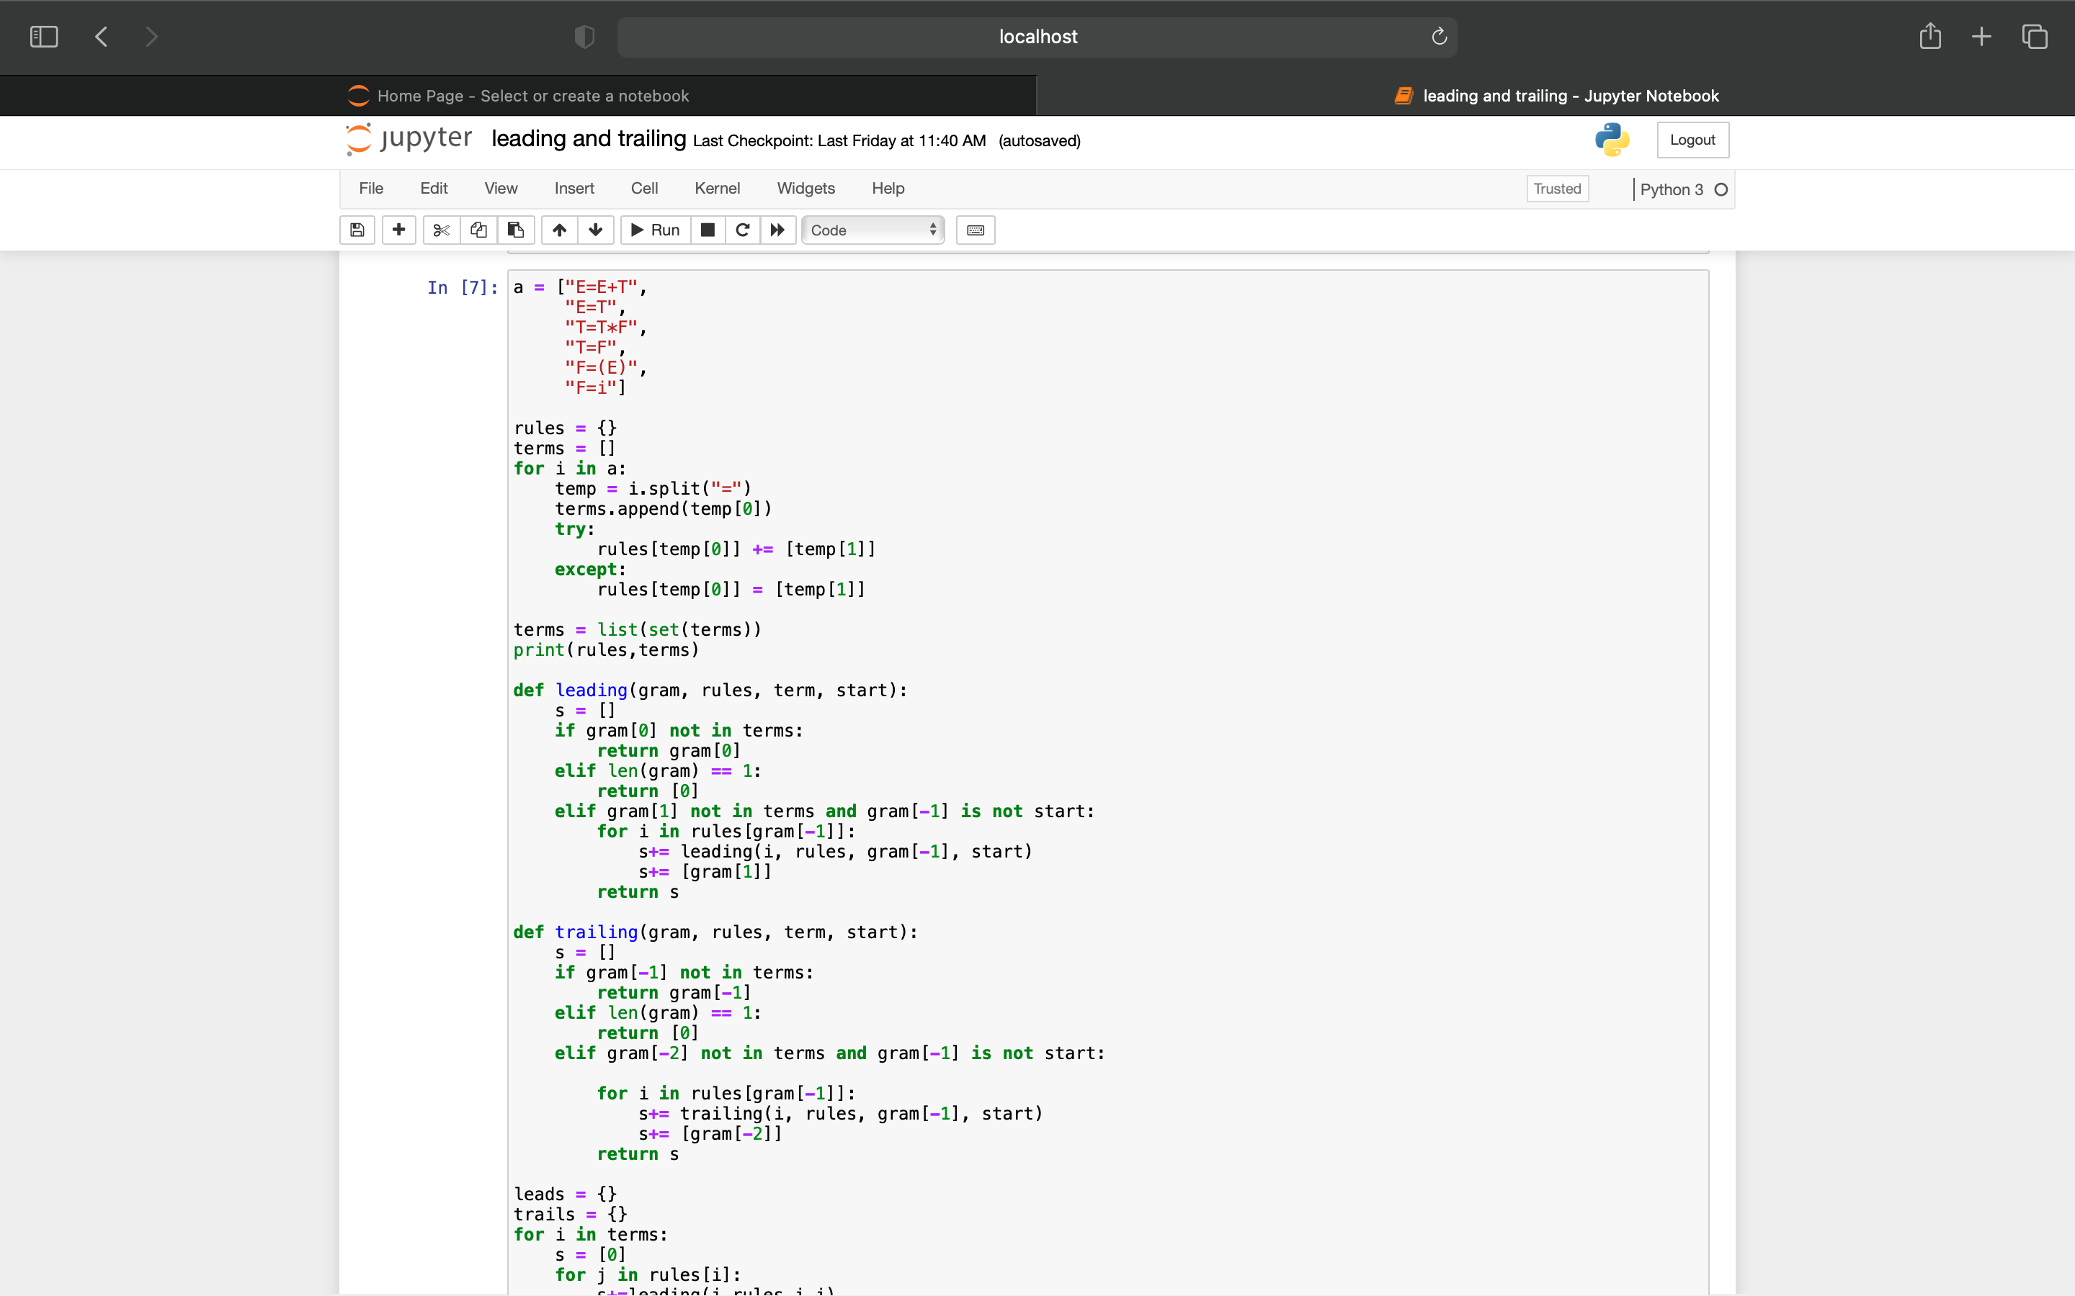

**Code:**



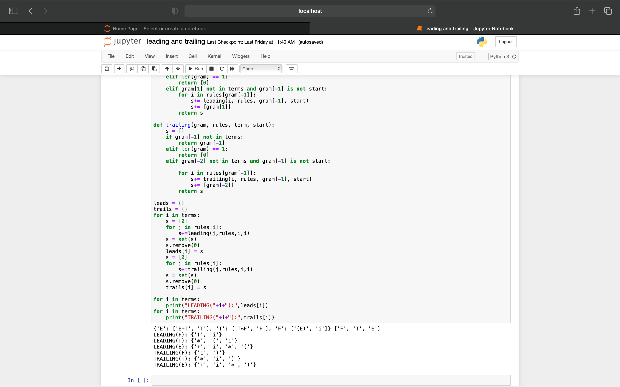

**Output:**

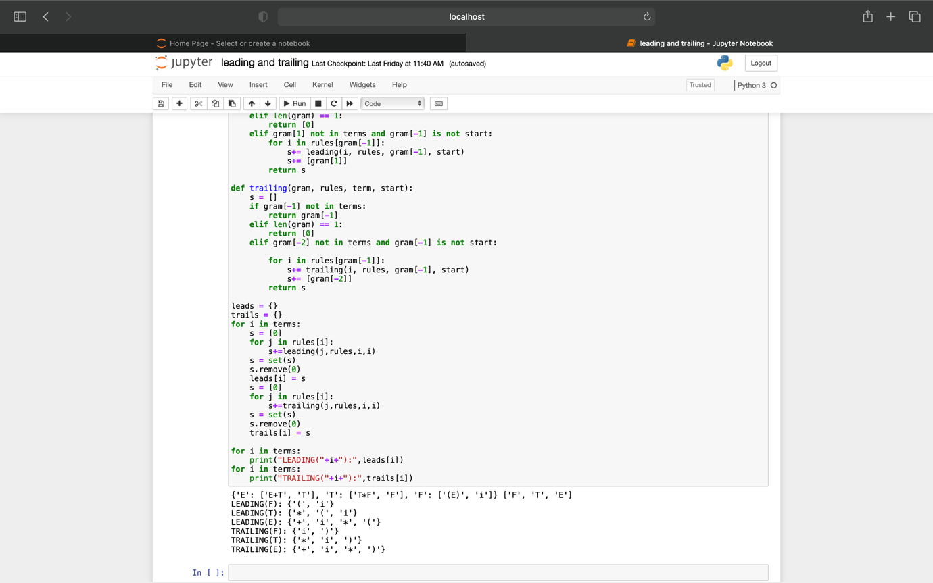

**Result:**

Hence, we have successfully computed leading and trailing for the given production.